Temsah Verilog
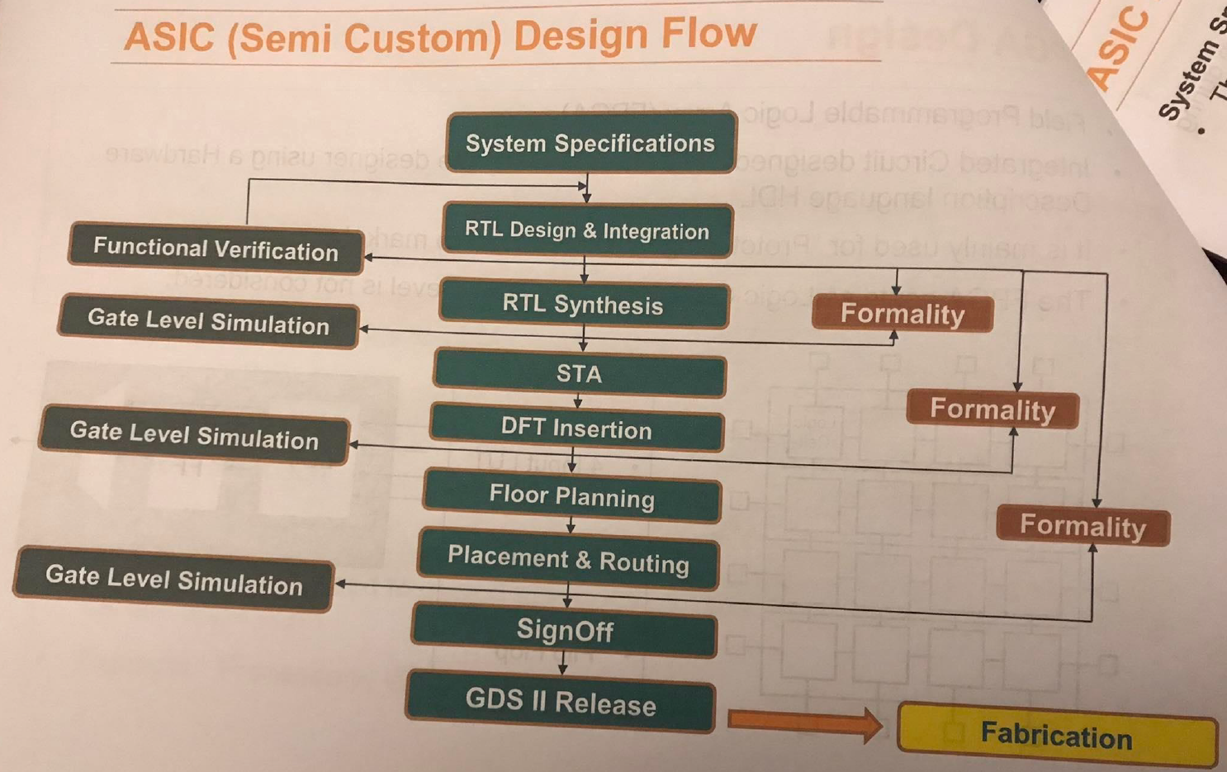
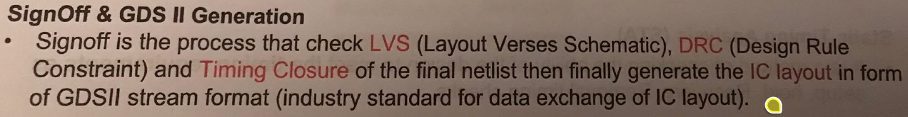
What is the problem with the following code?
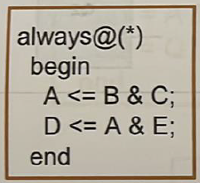
Answer: High chance of simulation-synthesis mismatch. Leeh? La2en bel nesba lel simulation, howa shayef non-blocking assignment, fa howa hay assign el RHS to the LHS at the end of the block. Thus, the simulation behavior will be:
A_next = B & C
D_next = A_old & C
That is, the simulator will use the old value of A while evaluating D. Nroo7 lel synthesis tool. Tyb howa ezay nesta5dem "A_old" de, mesh da keda ma3nah en lazem neb2a me5azenenha aslan? Yes, bs fi nafs el wa2t el synthesis tool hategy tbos hena hatla2y en de combinational always block, fa mayenfa3sh te infer flip flop, w fi nafs el wa2t mafeesh incomplete assignment 7asel, fa mayenfa3sh te infer latch. Tab omal hate3mel eh? 5alas hat behave as if blocking assignments were used, y3ny:
A_new = B & C
D_new = A_new & E
Hence, simulation-synthesis mismatch occurs.
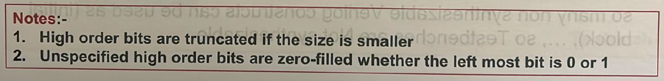
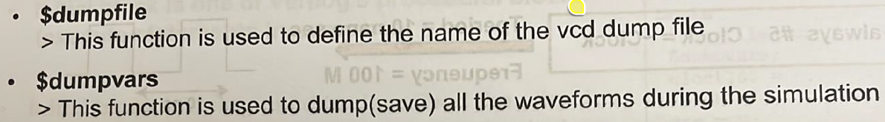
How can we generate a clock in the testbench?
always begin
#(CLK_PERIOD / 2.0) clk_tb = ~clk_tb;
end
What is the difference between $display and $monitor?
We need to call $display every time to track a variable value. On the other hand, $monitor can be called only once and it will print the values of the variables every time they change.

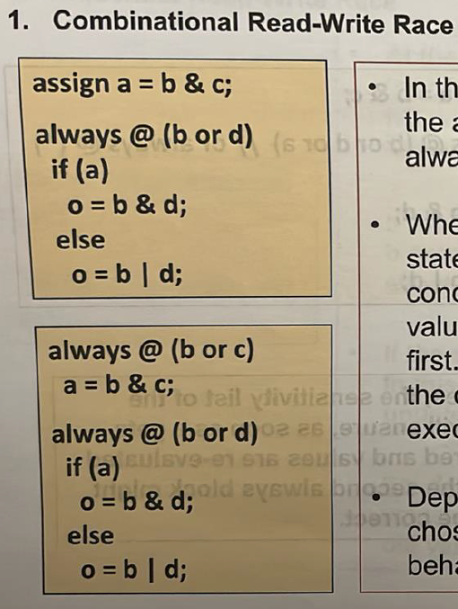
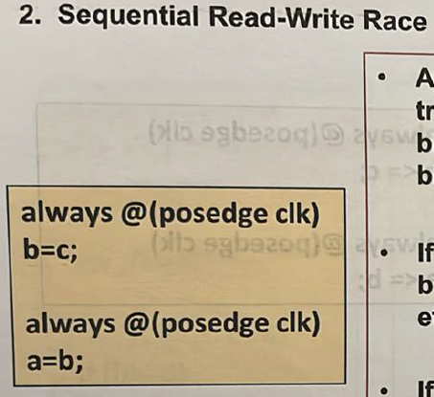
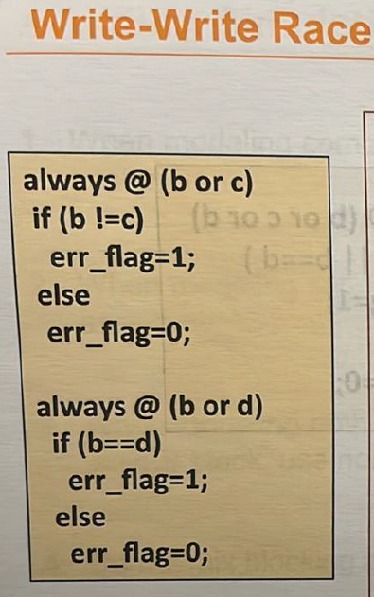
What is the difference between hard reset and soft reset?
There are commonly two types of reset:
- Hard reset: a global reset signal used to initialize the whole chip into a well‑known state (e.g., resetting all flip‑flops). It is typically asynchronous on assertion and synchronous on de‑assertion.
Examples:
- Power‑on Reset (PoR): a reset signal that is automatically asserted when power is applied to ensure the chip starts in a known safe state before normal operation.
- External reset pin: a chip‑level reset pin that can reset the entire chip at any time.
- Soft reset: a soft reset is an internal reset signal, usually synchronous, initiated by software or internal logic to reinitialize selected parts of the design only, without resetting the whole chip, typically during normal operation.
Compare between synchronous and asynchronous reset
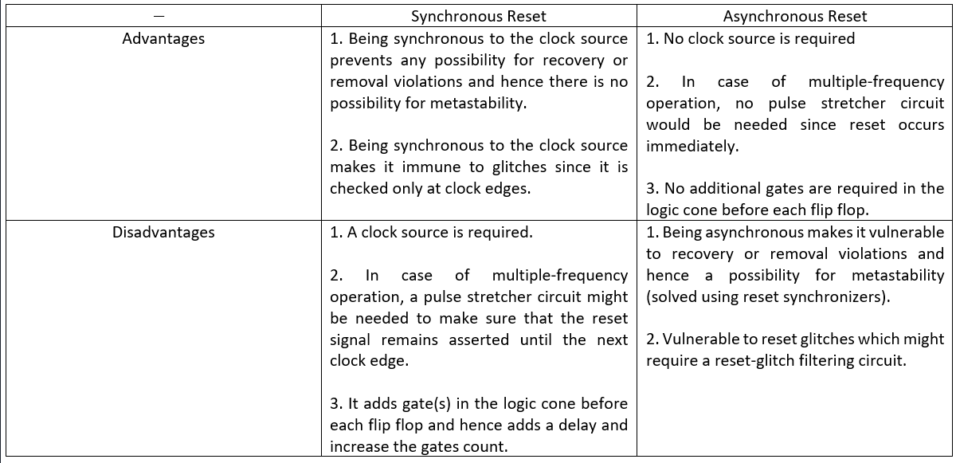
Compare Mealy and Moore in terms of latency and timing robustness.
- Latency: Moore can have more states because the outputs in Mealy react directly to inputs, so no need for wait states. For example, in Mealy, if we want the output to be high for a single cycle, we can simply raise it during the transition from the last state to the IDLE state. However, in a Moore machine, we would need to add an extra state for the output to be raised high in before transitioning to the IDLE state.
- Timing robustness: since Mealy's output can glitch, it has less timing robustness compared to Moore whose outputs are registered.
Which encoding to choose: binary, gray, or one-hot state encoding?
- One-hot state encoding trades off area and power for speed. It does so by using more state FFs (specifically, one FF per state) which simplifies the next-state logic and hence makes the circuit faster. So, for high-speed applications one-hot state encoding.
- If area and power are more important than speed, then it can’t be one-hot state encoding that uses more state FFs and hence more area and power. So, it’s either binary or gray encoding. Which one to choose? Area wise, both have the same number of state FFs ($\log_{2}\left(N\right)$ bits) as well as almost the same next-state logic. So, area wise, they are the same. Power wise, gray encoding can reduce switching power when states are traversed in order. So, power wise, gray encoding might be better than binary encoding or at worst the same. Thus, it makes sense to always use gray encoding and never use binary encoding whenever area and power are more important than speed.

Dr. Kareem Course 1
In a CMOS inverter, what is the forbidden region? Why is it forbidden?
- The forbidden region is the region in which both NMOS and PMOS are in the saturation region. It is called forbidden because it is of a very high gain (slope) which makes it sensitive to noise. This region is a favorable region for analog designers but not digital designers.
How can we pipeline the circuit below to maximize its throughput?
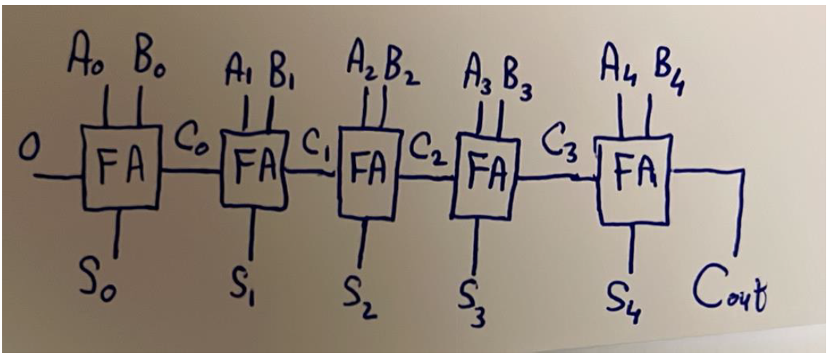
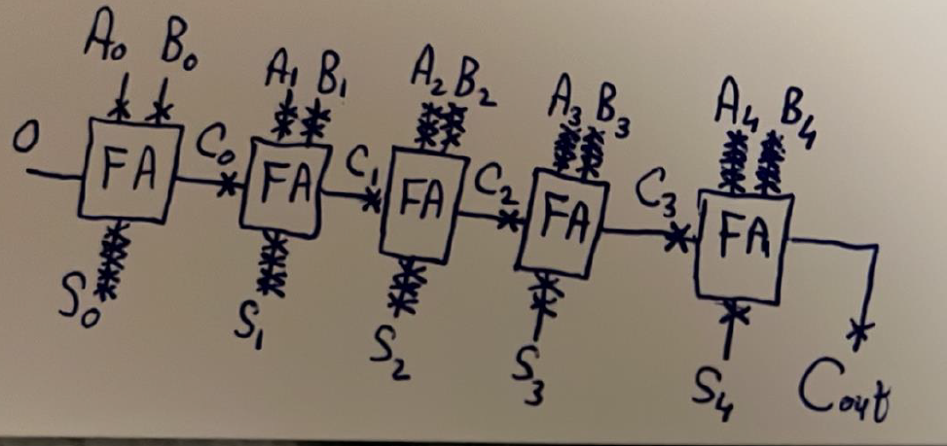

Temsah STA
What is the difference between propagation and contamination delays?
- Minimum propagation delay: the minimum time the output of a gate is guaranteed to be the correct value in the best‑case scenario when charging/discharging happens through the smallest resistance path → not important.
- Maximum propagation delay: the maximum time the output of a gate is guaranteed to be the correct value in the worst-case scenario when charging/discharging happens through the largest resistance → used in setup analysis.
- Contamination delay: the minimum time the output of a gate can begin changing, but this does not mean it has reached its final value (it can glitch) → used in hold analysis.
What is meant by minimum pulse width?
- A constraint set by the fab/foundry in the technology library (.lib) on the clock and asynchronous set/reset pins of a flip flop.
Where in the ASIC flow is the minimum pulse width checked?
- It is checked during STA. The most accurate part of the flow to do so is post-CTS and post-routing because the clock as well as the asynchronous set/reset signals will have taken their final tree and routes.
- How can we fix a setup violation?
  - The setup equation is: $t_{arrival}<t_{req}$. So, to fix a setup violation, we should either decrease the arrival time or increase the required time as follows:
    - $t_{arrival}=t_{cq}+t_{pd}$:
      - $t_{cq}:$ defined by the technology; not something to play with.
      - $t_{pd}$: can be decreased using one of the following techniques:
        - Pipelining.
        - Retiming.
        - Lower combinational gates delay ($τ∝RC$) by one of the following methods:
          - Increase driving strength (i.e. width) which would decrease extrinsic delay but not intrinsic delay. However, this would increase the load on the previous gate, so logical delay effort equation should be applied.
          - lowering the resistance ($R∝\frac{1}{I}=\frac{1}{\frac{K}{2}{\left(V_{DD}-V_{th}\right)}^{2}}$) by either increasing $V_{DD}$ (backend, rarely possible because it requires a different library unless you have multi-voltage domains) or decreasing $V_{th}$ (backend, possible if the library has multiple threshold voltage flavors).
    - $t_{req}=t_{clk}-t_{su}+t_{skew}$:
      - $t_{clk}$: spec, rarely acceptable to play with (unless you can scale frequency in some relaxed blocks).
      - $t_{su}$: defined by the technology; not something to play with.
      - $t_{skew}$: apply positive skew.
- How can we fix a hold violation?
  - The hold equation is: $t_{arrival}>t_{req}$. So, to fix a hold violation, we should either increase the arrival time or decrease the required time as follows:
    - $t_{arrival}=t_{cq}+t_{pd}$:
      - $t_{cq}:$ defined by the technology; not something to play with.
      - $t_{pd}$: can be increased using one of the following techniques:
        - Buffering.
        - Higher combinational gates delay ($τ∝RC$) by one of the following methods:
          - Increasing the resistance ($R∝\frac{1}{I}=\frac{1}{\frac{K}{2}{\left(V_{DD}-V_{th}\right)}^{2}}$) by either decreasing $V_{DD}$ (backend, rarely possible because it requires a different library unless you have multi-voltage domains) or increasing $V_{th}$ (backend, possible if the library has multiple threshold voltage flavors).
    - $t_{req}=t_{h}+t_{skew}$:
      - $t_{h}$: defined by the technology; not something to play with.
      - $t_{skew}$: apply negative skew.

Dr. Kareem Course 2

Wires
- The wire model is as shown below:
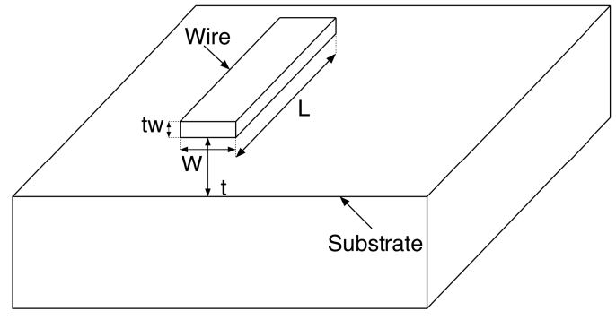
- $τ_{wire}∝RC=\frac{ρL}{A}×\frac{ϵA}{d}=\frac{ρL}{Wt_{w}}×\frac{ϵWL}{t}=\frac{ρϵL^{2}}{t_{w}t}∴τ_{wire}∝\frac{L^{2}}{t_{w}t}$
- As technology advances, transistors become smaller, hence they become closer to each other, which means local wires become shorter. But does this mean their delay become smaller? No, because all other dimensions scale down as well, hence $τ_{wire}∝\frac{{\left(\frac{L}{k}\right)}^{2}}{\frac{t_{w}}{k}.\frac{t}{k}}=\frac{L^{2}}{t_{w}t}$, which means the delay of local wires remains constant as technology advances.
- As technology advances, chips become larger, which means global wires become longer, hence $τ_{wire}∝\frac{{\left(k_{w}L\right)}^{2}}{\frac{t_{w}}{k}.\frac{t}{k}}=k^{2}k_{w}^{2}.\frac{L^{2}}{t_{w}t}$, which means the delay of global wires increases dramatically as technology advances.
- Accordingly, wires delay became the significant source of delay in advanced chips:
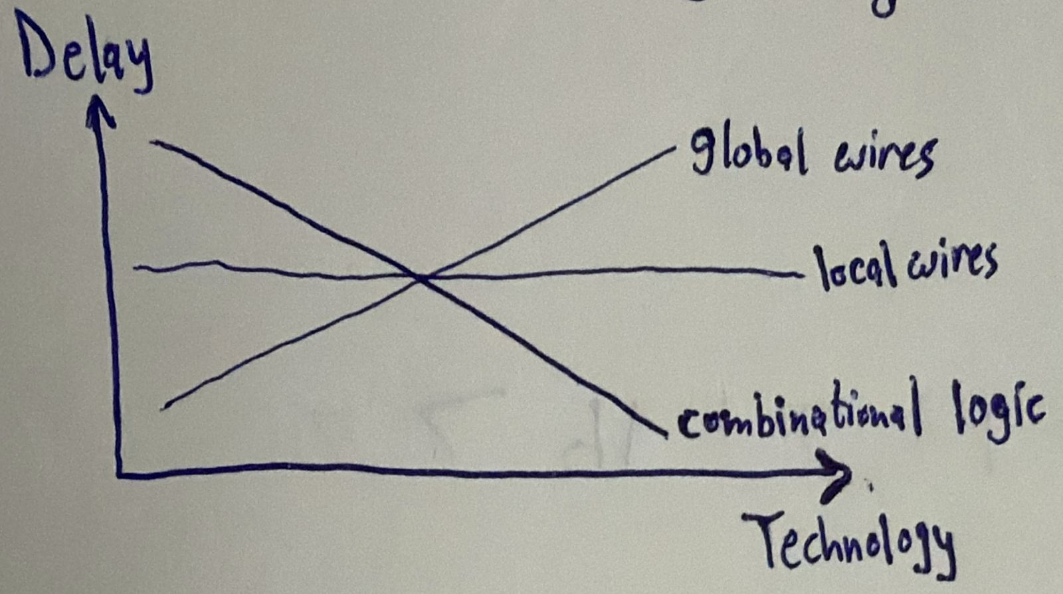
- One way to mitigate the global wires delay is to increase the wires thickness $t_{w}$. However, increasing the wires thickness $t_{w}$ leads to the increase of a type of capacitance called interwire capacitance that causes crosstalk between adjacent wires. To decrease interwire capacitance, adjacent wires have to be farther separated. This leads to hierarchical routing:
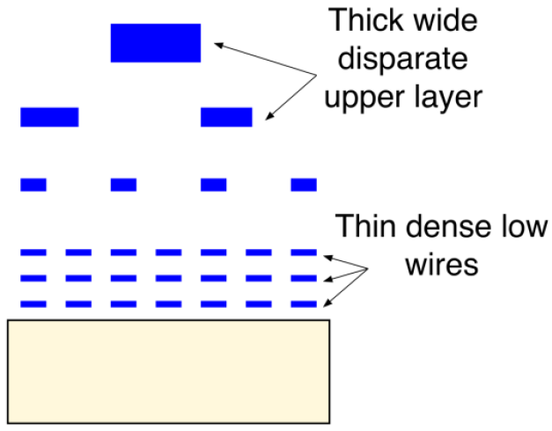
- Wires in higher metal layers are made thicker to decrease the delay, but to avoid the increase of interwire capacitance, they are farther separated. Hence, wires in higher metal layers are used for global routing, while wires in lower metal layers are used for local routing.

Clock
What is “clock skew”?
- It is the difference in the arrival time of the clock between flip flops resulting from different propagation delays from the chip clock pin to different flip flops.
Describe the nature of clock skew.
- Clock skew is deterministic and spatial. Deterministic because once all flip flops are placed, CTS is built, and clock is routed to all flops, we know the skew between two flip flops. Spatial because clock skew is function of space; changing the location of two flip flops relative to each other can change the clock skew between them.
What is clock jitter?
- It is the deviation of the clock edges from the ideal timing (e.g. $T_{s}+δ$ instead of $T_{s}$) due to phase noise in oscillators.
Describe the nature of clock jitter.
- Clock jitter is stochastic and temporal. Stochastic because it is random (normally distributed), and temporal because it changes from time to time.
How does clock jitter affect hold analysis?
- Clock jitter has no effect on hold analysis because hold analysis is done on a single clock edge, so even if jitter moved the edge, it moves it simultaneously at all registers.

Clock Domain Crossing (CDC)
Assume two clocks of the same frequency 50 MHz are generated from two different clock sources. Are they synchronous?
- No, the two clocks are asynchronous because each clock source can have its own initial random settling time, which would cause them to have a non-constant phase relationship.
How would the output of a flip flop behave in case it became metastable?
- Scenario 1: lw enta ghayart el input orayeb awy men el clock edge, fa el flip flop mesh hayshoof el taghyeer da w hayezhar fel clock cycle el bad3eha.
- Scenario 2: lw enta ghayart el input fel nos mabeen el setup time wel clock edge, fa el output hy glitch, y3ny hayro7 lel output bta3 el input el geded w yerga3 tany, wel output el sa7 da hayezhar el clock cycle el ba3deha.
- Scenario 3: lw enta ghayart el input b3d el setup time 3la tool, fa el output el sa7 hayezhar fi nafs el clock cycle bs b3d wa2t atwal men el expected el howa $t_{cq}$.
These 3 scenarios apply to hold time as well, kol el far2 eno b3d el edge badal ablo.
What issue can arise from a metastable flip flop having a larger $t_{cq}$?
- This could cause the propagation of different values at the same time:
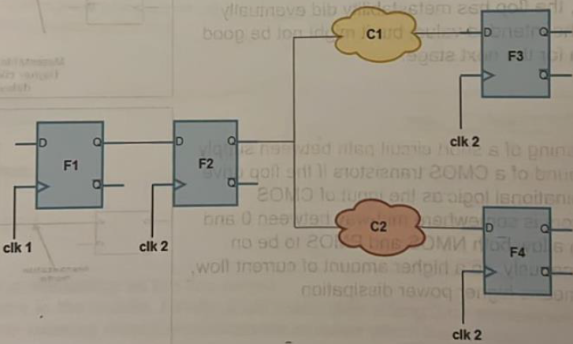
What uncertainty does a double-flop synchronizer have?
- It has a one-cycle uncertainty; the output of a double-flop synchronizer can be ready after 2 or 3 cycles depending on when the first flop got out of metastability.
What does a Gray synchronizer guarantee?
- It guarantees that no garbage data would ever appear on the bus (like what would happen with using multiple double-flop synchronizers with a bus); only either the old value or the new value.
Describe handshaking synchronization
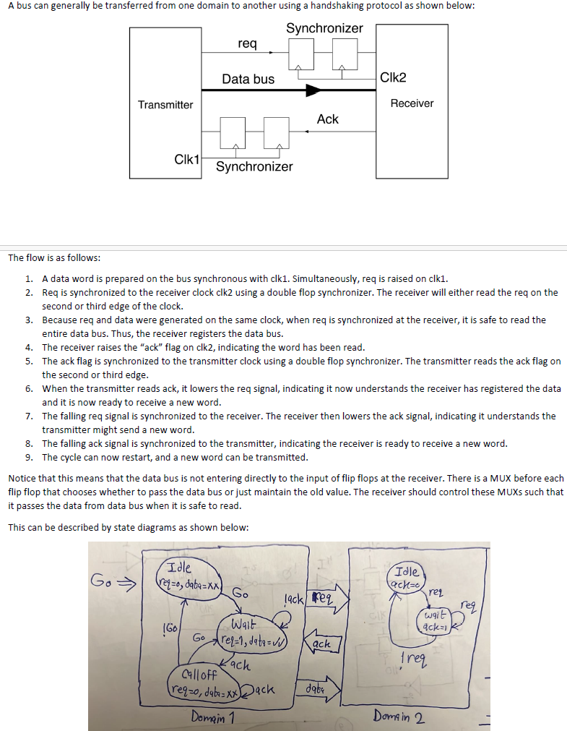
Calculate the FIFO depth for the following example:
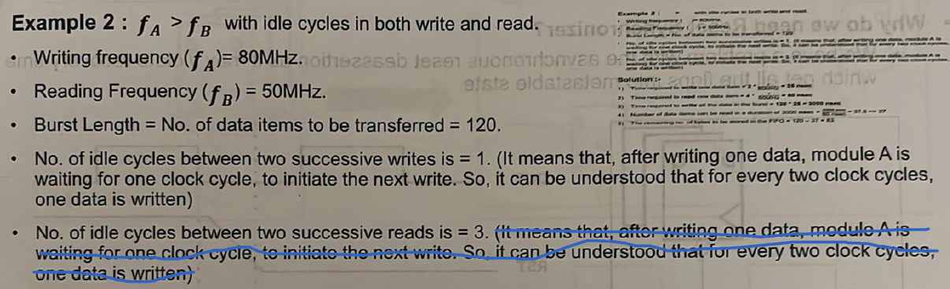
In general, what should the depth $D$ of an asynchronous FIFO be for a Tx write rate of $f_{A}$, Rx read rate of $f_{B}$, Tx idle write cycles $i_{A}$, Rx idle read cycles $i_{B}$, and data burst of $L$ words?
- Lw el Rx mesh beye2ra haga 5ales, yeb2a $D=L$.
- Bs el Rx beye2ra athna2 ma el Tx beyekteb. 5alas yeb2a nsheel men el depth el goz2 el howa 2arah. Tab howa 2ara 2ad eh? 7asab el ratio mabeen $f_{B}$ w $f_{A}$. Yeb2a $D=L-\frac{f_{B}}{f_{A}}L=\left(1-\frac{f_{B}}{f_{A}}\right)L$.
- Tab wel idle cycles? El idle cycles heya ka2en bzbt el rate bta3 el Tx wel Rx got divided by the number of idle of cycles + 1. Y3ny keda $D=L-\frac{f_{B}}{f_{A}}L=\left(1-\frac{f_{B}/(i_{B}+1)}{f_{A}/\left(i_{A}+1\right)}\right)L$.
- N7ot ceiling bs 3ashan lw tele3 fractional:
$$D=ceil\left[\left(1-\frac{f_{B}/(i_{B}+1)}{f_{A}/\left(i_{A}+1\right)}\right)L\right]$$
Draw the reset synchronizer circuit
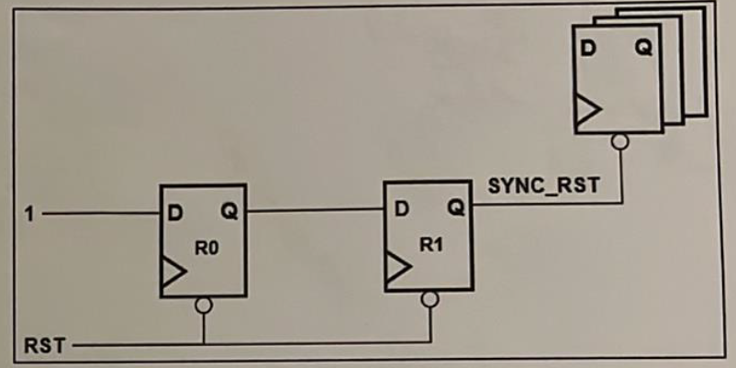

Temsah Synthesis
What is the set_clock_latency constraint used for?
- It is used to define either source latency (set_clock_latency -source 5 [get_clocks sys_clk]) or network latency (set_clock_latency 5 [get_clocks sys_clk]). Source latency models the delay from the clock source (e.g. PLL or external clock) to the clock definition point, while network latency models the delay from the clock definition point to the clock pins of the flip-flops.
What is the importance of source latency versus network latency?
- Source latency represents the delay from the clock source to the clock definition point. In a single‑clock design with purely internal register‑to‑register paths, source latency usually does not affect timing, because it shifts the launch and capture clocks equally and therefore cancels out in both setup and hold analysis. However, source latency becomes important in other contexts (e.g. I/O timing or multi‑clock designs). Network latency models the delay from the clock definition point to individual flip‑flop clock pins. Unlike source latency, network latency directly affects the relative clock arrival times between different flops and therefore defines clock skew. This makes network latency particularly important in early STA before clock‑tree synthesis, because it allows the designer to model expected skew and identify potential setup or hold issues before the real clock tree is built.
Is the set_clock_uncertainty constraint used with setup or hold analysis?
- It can be used with both as shown below:
$$set_clock_uncertainty -setup 0.2 [get_clocks clk]$$
$$set_clock_uncertainty -hold 0.05 [get_clocks clk]$$
What is the set_clock_transition constraint used for?
- It is used to define the rise and fall times of the clock.
Does there exist a single .lib library provided by the fab?
- Not necessarily, the fab can provide multiple .lib libraries each for a different PVT corner:
  - SS library (slow-slow process, low V, high temp)
  - TT library (typical-typical process, typical V, typical temp)
  - FF library (fast-fast process, high V, low temp)
The fab can also provide a single .lib library with multiple PVT corners called operating conditions, and we can select a specific operating condition using set_operating_condition constraint.
How can wires be modelled in the synthesis step?
- Using the set_wire_load_model defines a wire load model to estimate the wires’ resistance and capacitance and hence estimate their delay.
How do we tell the synthesis tool not to analyze CDC paths?
- By either using set_false_path for two specific clock domains OR using set_clock_groups in case of many clock domains.
What precaution should we take when using the set_multicycle_path constraint?
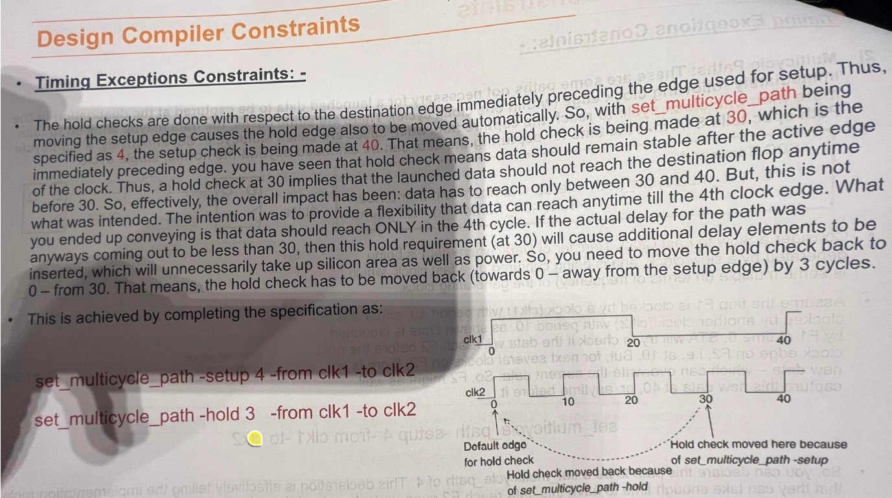

Temsah Power
What are the sources of power consumption?
- Static power:
  - Leakage power:
    - Subthreshold leakage: when $V_{gs}<V_{th}$, the transistor is not just “off”, it is in the subthreshold region where current flows and hence leakage occurs.
    - Gate oxide tunnelling: the oxide layer thickness between the gate and channel scales down, hence at some point it allows gate current and hence leakage occurs.
- Dynamic power:
  - Switching power
  - Short-circuit power: to cancel it, $V_{DD}=2V_{th}$.
  - Glitch power: it is nothing but a mix of switching power and short-circuit power. Due to glitches, the activity factor ($α$) of a signal can exceed 1.
Mention power reduction techniques
- Switching power reduction techniques:
  - Activity factor ($α$):
    - Clock gating.
    - Avoid using XOR gates as much as possible (e.g. comparators).
    - Operand isolation.
    - Use shifters instead of constant multiplications.
  - Load capacitance ($C_{L}$):
    - Gate capacitance: use smaller gates (but need to have a slack).
    - Wire capacitance: do better floor planning, placement, and routing to decrease the wires’ length.
  - Frequency ($f$): multiple frequencies.
  - Supply voltage ($V_{DD}$): multi-voltage domains.
- Short-circuit power reduction techniques:
  - Multi-threshold domains.
- Glitch power reduction techniques:
  - Operand isolation.
- Leakage power reduction techniques:
  - Multi-threshold domains.
  - Power gating.
What is the problem of using an AND gate for clock gating?
- “Pulse clipping” and minimum pulse width violation.
- Setup/hold time violation.
Draw the latch-based clock gating cell.
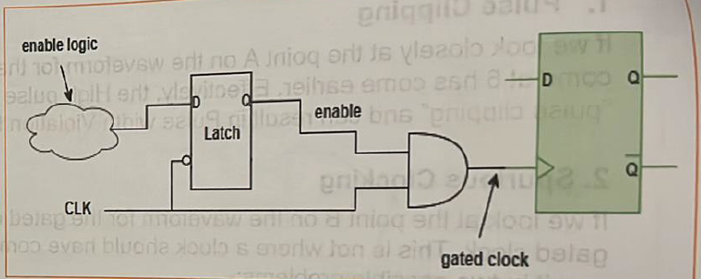
From power point of view, should we increase or decrease $V_{th}$?
Increase $V_{th}$ because:
- Static power: subthreshold leakage current is a function of $V_{th}$; increasing $V_{th}$ reduces subthreshold leakage current.
- Dynamic power: increasing $V_{th}$ shrinks the overlap region where NMOS and PMOS conduct simultaneously. Accordingly, increasing $V_{th}$ decreases short-circuit power.
How is power gating done?
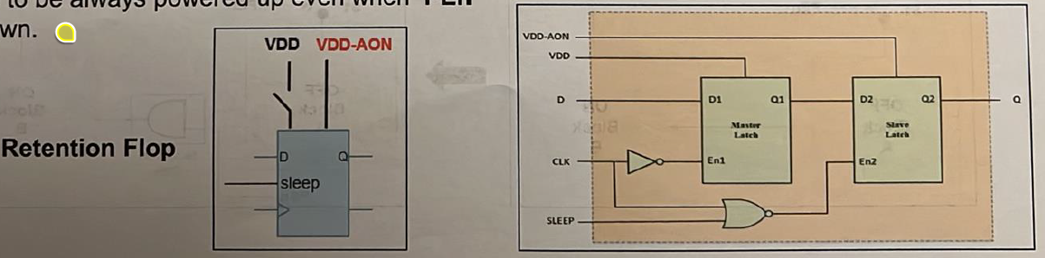
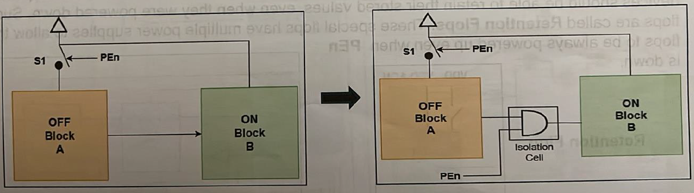

Lint
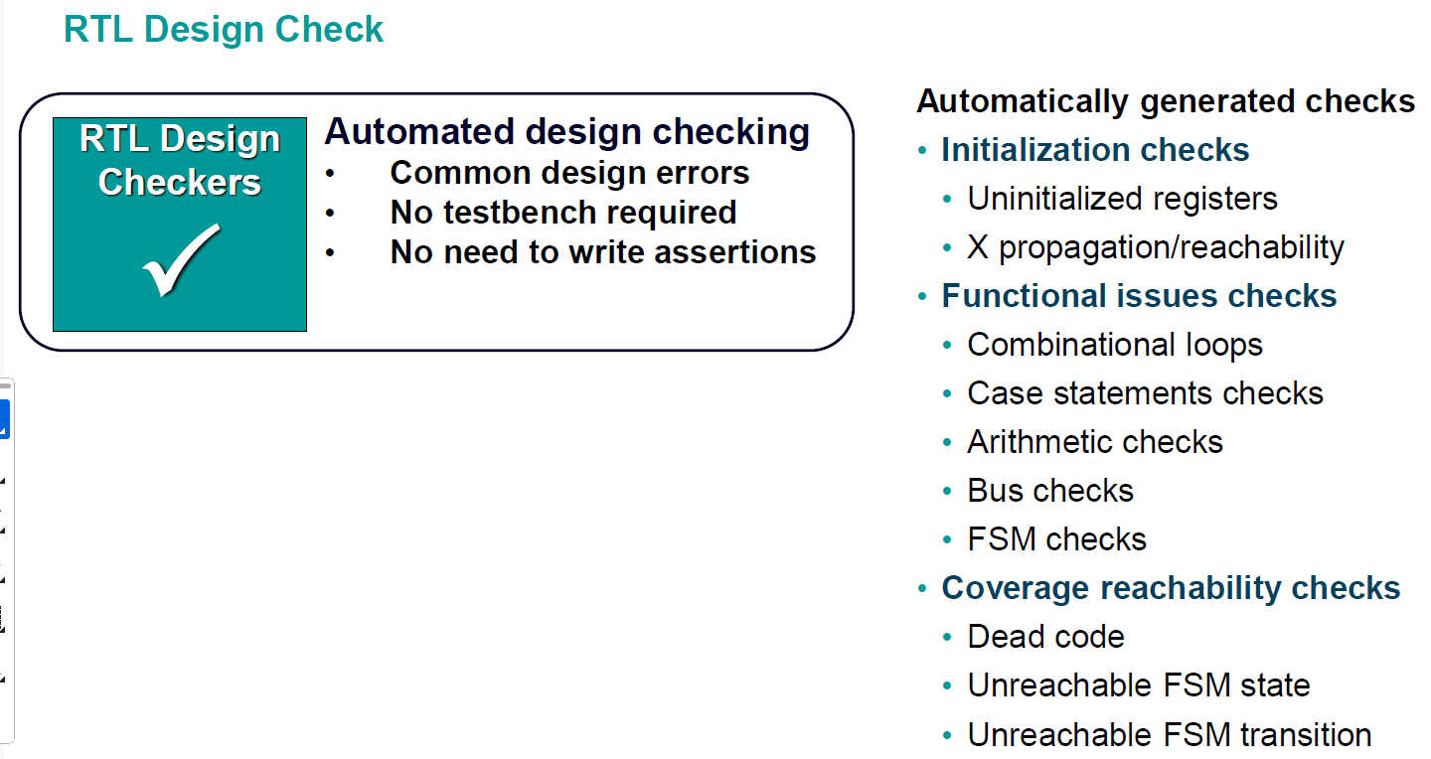

Temsah Formal Verification
How is equivalence checking done?
- You give the formal engine the RTL and a gate-level netlist, and through mathematical transformations and Boolean equations, the tool compares the functional equivalence checking between both. This is done through dividing the design into logic cones and compare points.
What is model checking?
- Da el inputs bta3to mesh RTL w netlist b2a, la2 da el input bta3o RTL w a set of properties/specifications enta 3ayezha tefdal met7a2a2a 3la tool (e.g. SystemVerilog Assertions), w el haye3melo el model-checking engine eno exhaustively hay go through all possible states in your design b7ees ye make sure en el properties de dayman met7a2a2a, w lw la2a case mesh met7a2a2a fiha, hayedelak el set of inputs (i.e. stimulus) el bey5aly property mesh met7a2a2a, which we call a counterexample.

Temsah DFT
What are the possible issues during fabrication/manufacturing?
- Short circuit
- Open circuit
- Stuck-at-1
- Stuck-at-0
How are controllability and observability before and after DFT logic insertion?
- Before DFT, controllability and observability are harder because the nearer a gate is to the input, the easier it is to control its inputs, but the harder it is to observe its output, and the nearer a gate is to the output, the easier it is to observe its output, but the harder it is to control its inputs.
- The DFT logic improves controllability and observability through replacing all flip flops in the design with scan flops. A scan flop is nothing but a normal flip flop with an input multiplexer with a “scan enable” selection line that selects between either the functional path (i.e. the normal design path) and the scan path. This way, we can build a long shift register starting from a scan input port to the chip, which can be used by the ATE tool to pass in the test pattern generated by the ATPG for testing the chip for manufacturing defects.
- Every scan chain has its own Scan Enable (SE) & Scan Input (SI) input ports and Scan Output (SO) output port.
What are the steps of DFT?
- DFT testing consists of 3 steps (check the example below):
  - Shift in: set SE = 1, SI port to the value you want to drive the target node with, and then wait until SI’s value reaches the target node.
  - Capture: once the SI’s value reached the target node, now set SE = 0 to activate the functional path.
  - Shift out: the next clock cycle, set SE = 1 again to shift the captured value to the output of the scan chain.
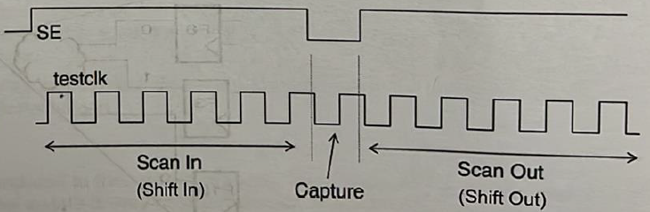
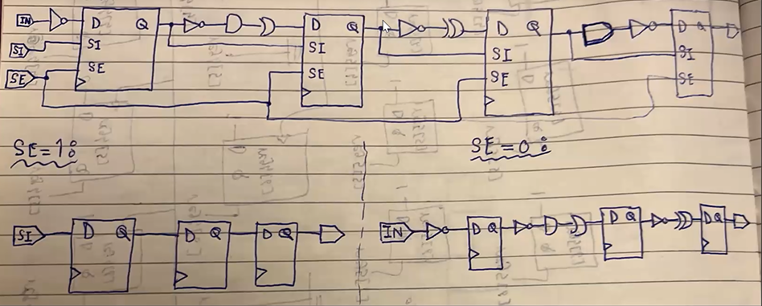
What does the “coverage” number reported by the DFT tool represent?
- It indicates the percentage of nodes the ATPG can activate and observe.
What is the timing overhead of adding the DFT logic?
- The additional multiplexer at the input of each flip flop causes a higher setup requirement on the functional paths.
- Scan flops have higher clock-to-q delay as the flop now drives an additional load, which is the scan-in port of the next flop.
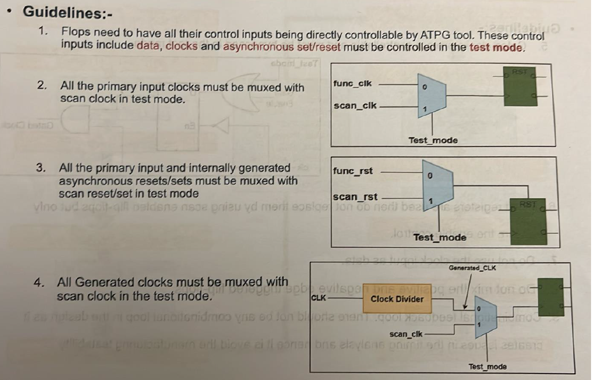
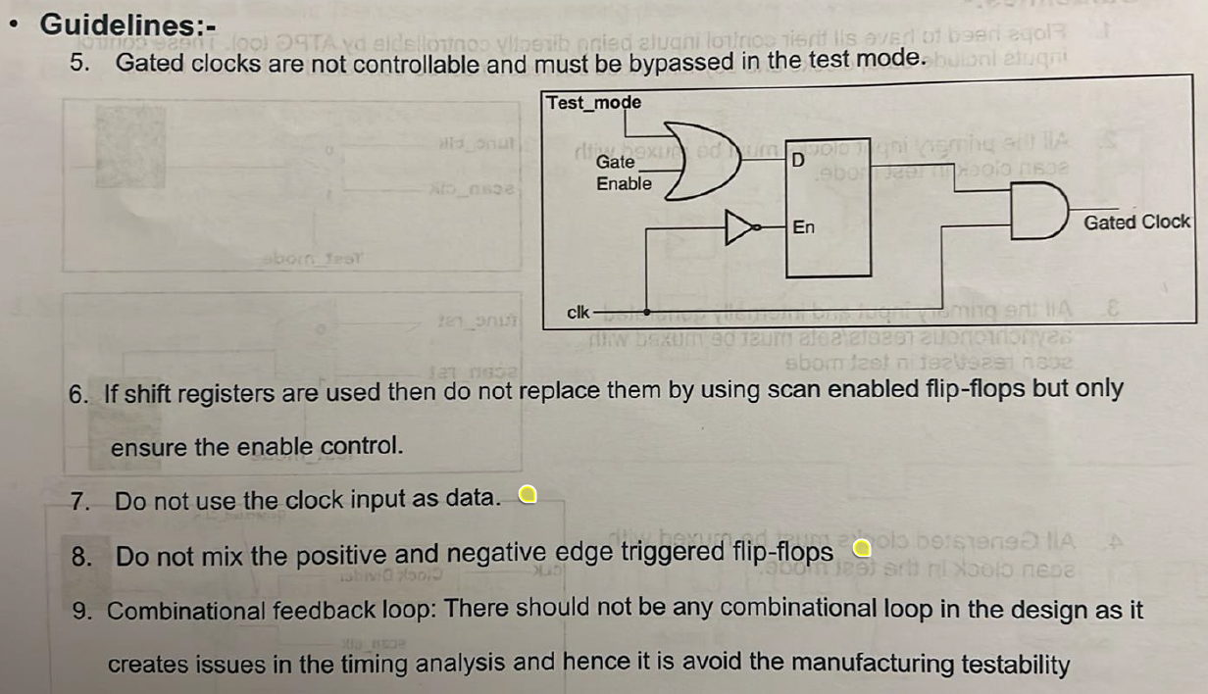

Code/Functional Coverage
What is code coverage and functional coverage?
What might be the reason of 100% code coverage and 20% functional coverage? Who to blame, the designer or the verifier?
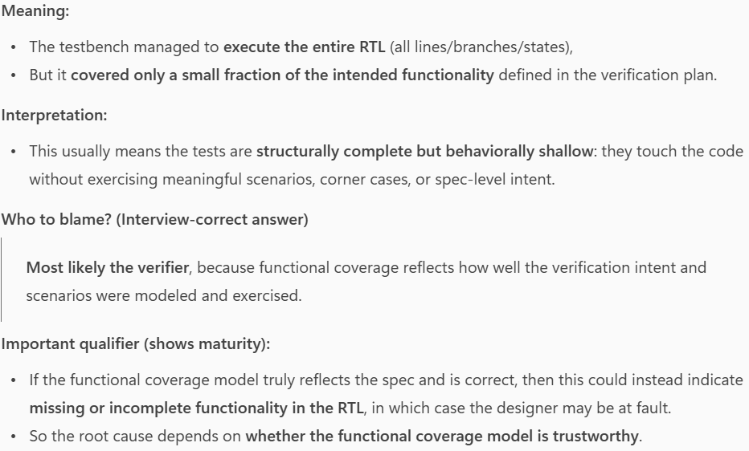
What might be the reason of 20% code coverage and 100% functional coverage? Who to blame, the designer or the verifier?
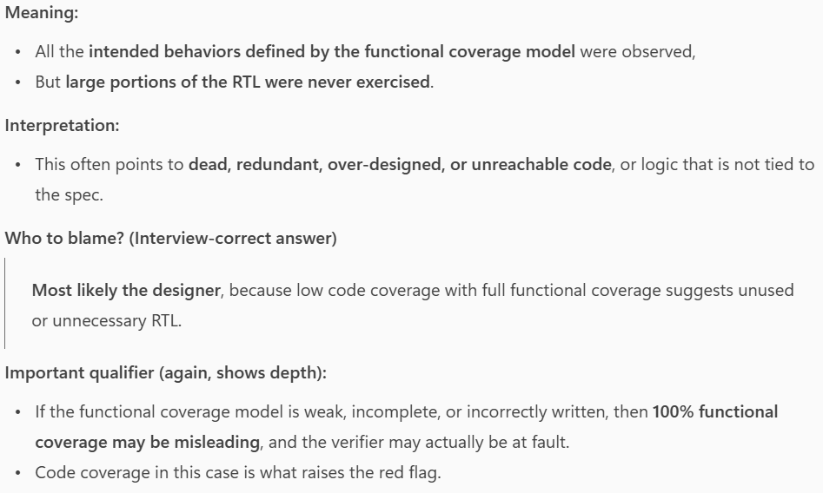

DSP Design Guide
Nothing worth writing really.

FPGA
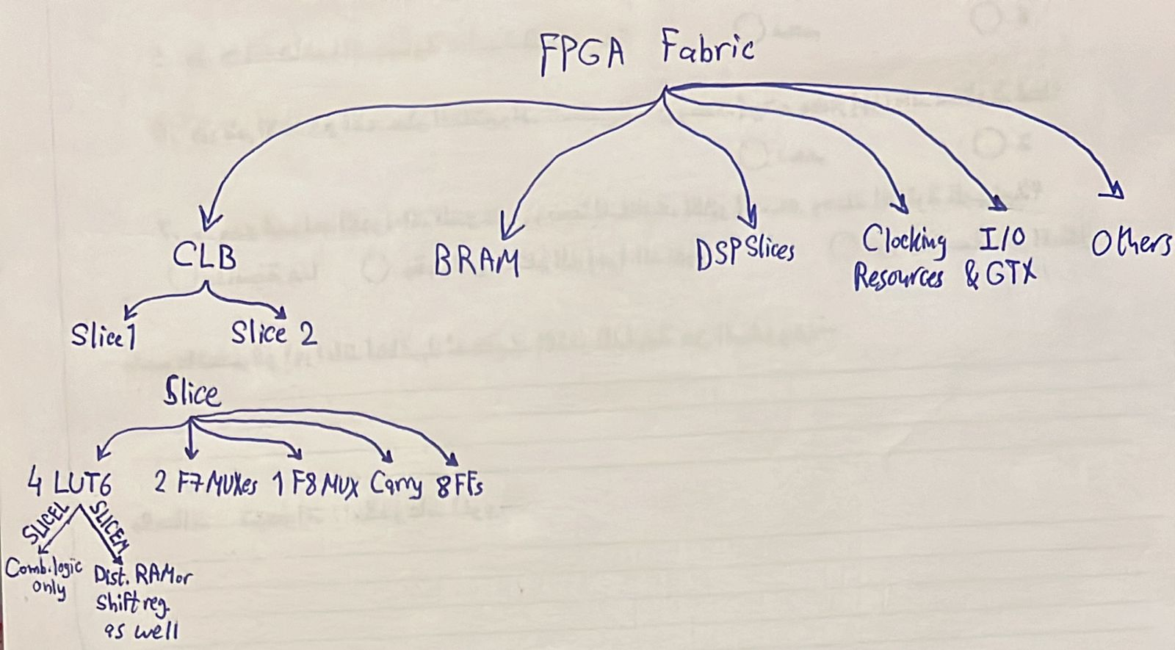
SEARCH FOR FPGA INTERVIEW QUESTIONS AND WRITE THE GOOD ONES HERE

DPD
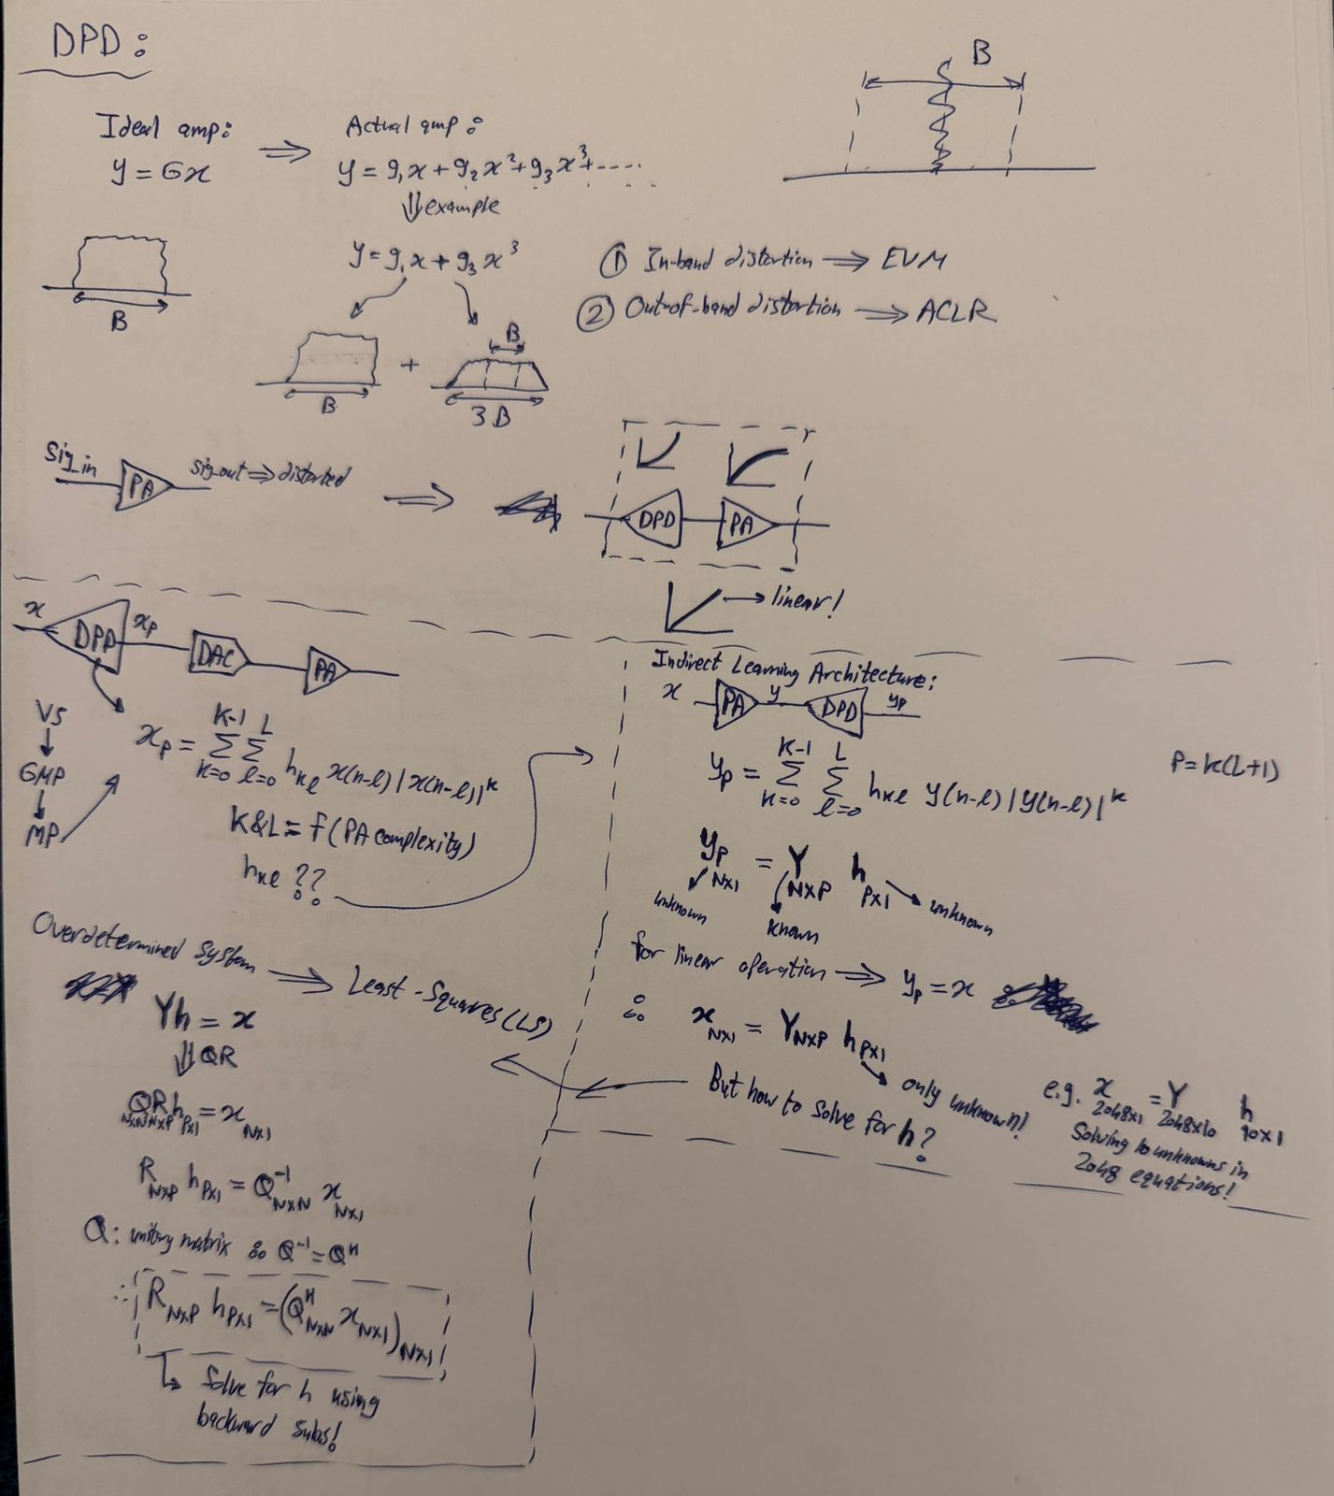
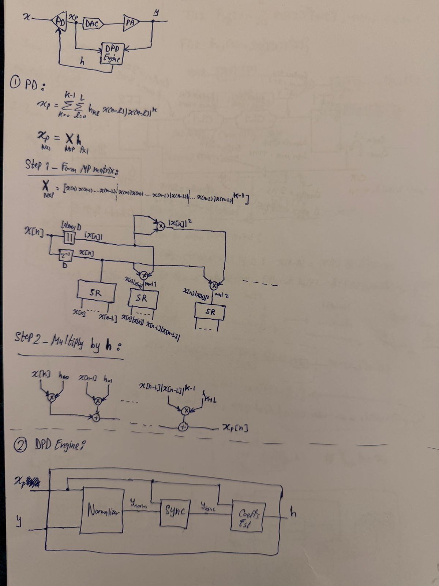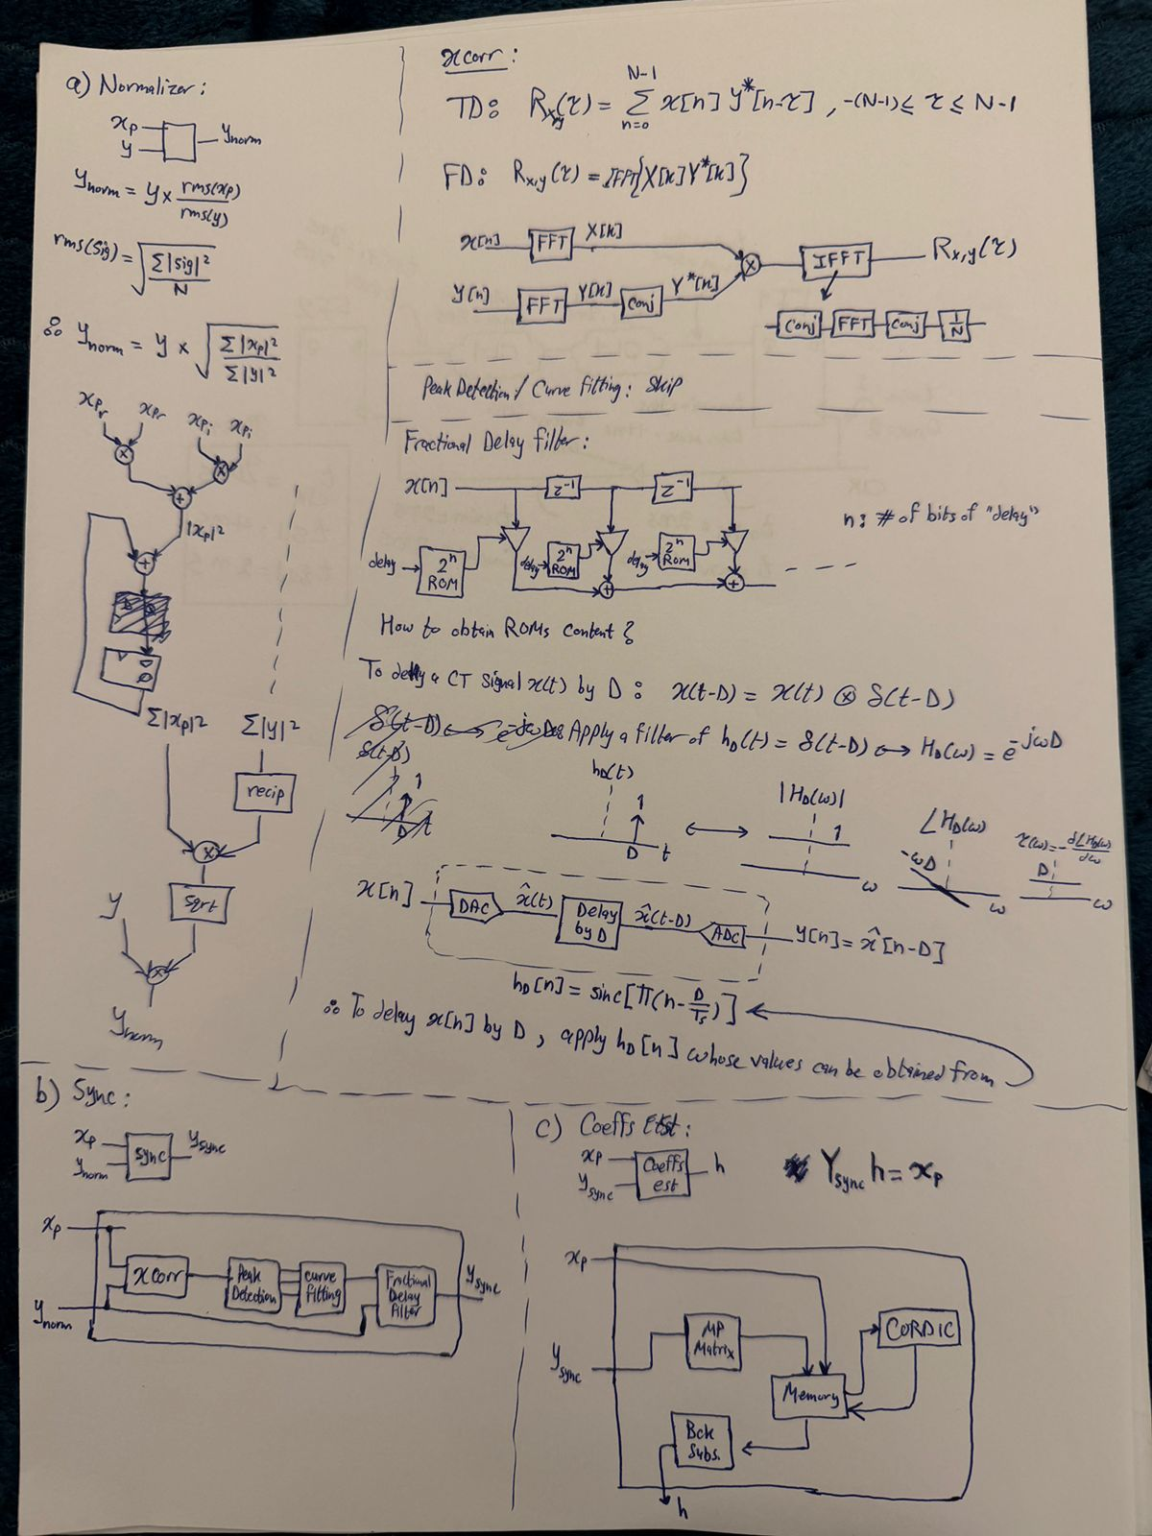

Dr. Kareem Book (Chapters 3, 8, 6)
RE-READ CHAPTERS 3 & 8 AND TAKE NOTES HERE

SystemVerilog
CHECK YOUR BOOK SUMMARY AND TAKE NOTES HERE

Others
- From ADI’s internship interview timing question: always mix max and min delays during analysis 3ady to design for the worst case scenario. Even STA tools do this because, in reality, even on a single FF or SS chip, one path can behave “fast” while another behaves “slow.” Fa el sa7 enena ne mix el min wel max delays 3ady.
Where does the clock come from?
- The clock originates from a reference oscillator, typically a crystal oscillator. This reference clock is fed into a PLL, which synthesizes the internal clocks used by the digital logic by multiplying, dividing, and conditioning the frequency. So:
Oscillator → Ref Clock (e.g. 25 MHz) → PLL → High-Speed Clock (e.g. 1.9 GHz)
Write down 3-bit and 4-bit Gray counts
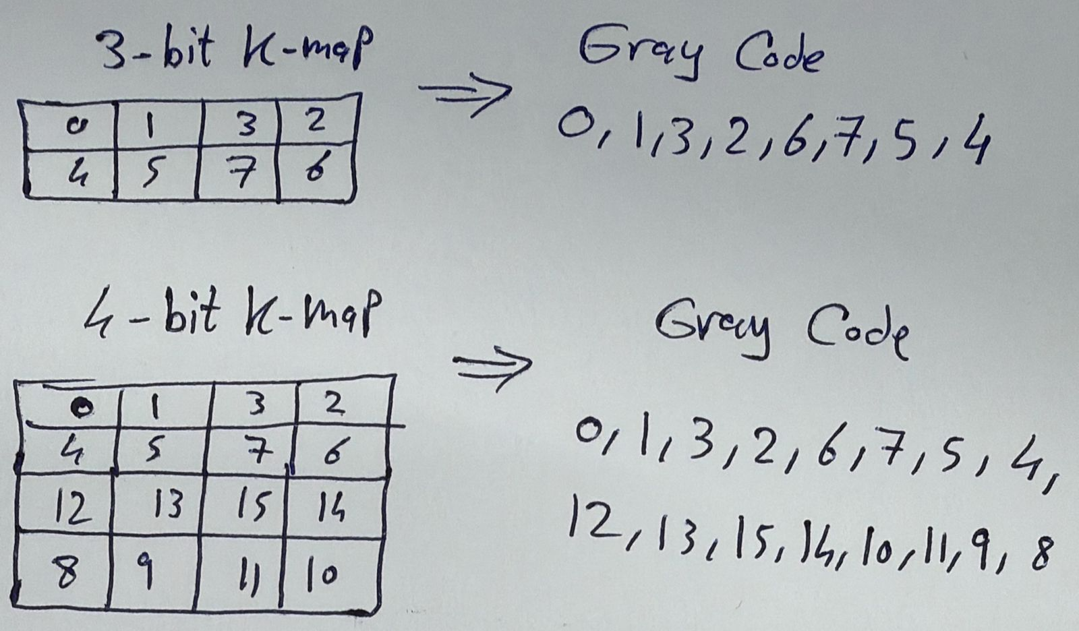

Reuse Methodology Book
3ADDY 3AL KETAB BSOR3A W 5OD MENO EL NOTES EL MOHEMA

“Interview Questions” Folder
“Why don’t we use latches in design?”
- “Data has only $\frac{T_{clk}}{2}$ to propagate from one latch to another, while flip flops allow data to propagate in $T_{clk}-t_{su}$.
  - Being level triggered, latches are vulnerable to glitches.
  - Place and route tools find it harder to achieve timing closure in latch-based designs. Watch this from 5:20 to the end.”
How can we use AND/NAND and OR/NOR to make buffers/inverters?
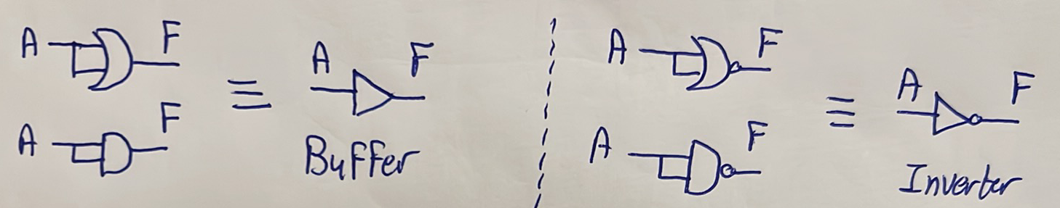
What is the procedure we should follow to make any gate using NAND or NOR gates?
- Write the expression of the target gate.
- Play with the expression (e.g. use De Morgan’s theorem) to write it in terms of the available gate (NAND or NOR) and inverters.
- Every time the available gate (NAND or NOR) or an inverter appears in the expression, take it and name it as a new variable.
What conversions do we need to memorize?
- Normal conversion steps (previous question).
- NAND to XOR and NOR to XOR.
- XNOR will be just the inversion of the XOR gate obtained in the previous step.
Make a NOR gate using NAND gates only
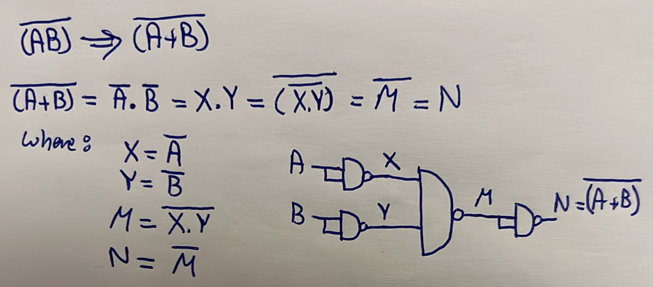
Make an XOR gate using NAND gates only
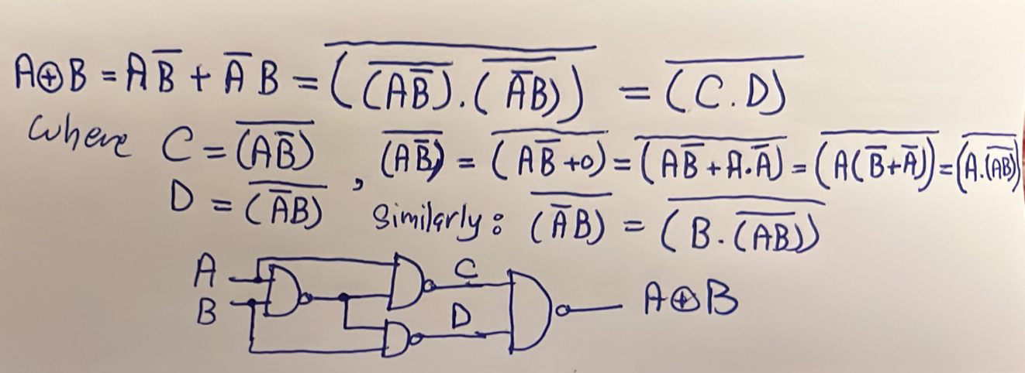
Make an XNOR gate using NAND gates only
- Just put an inverter after the previous circuit
Make an XOR gate using NOR gates only
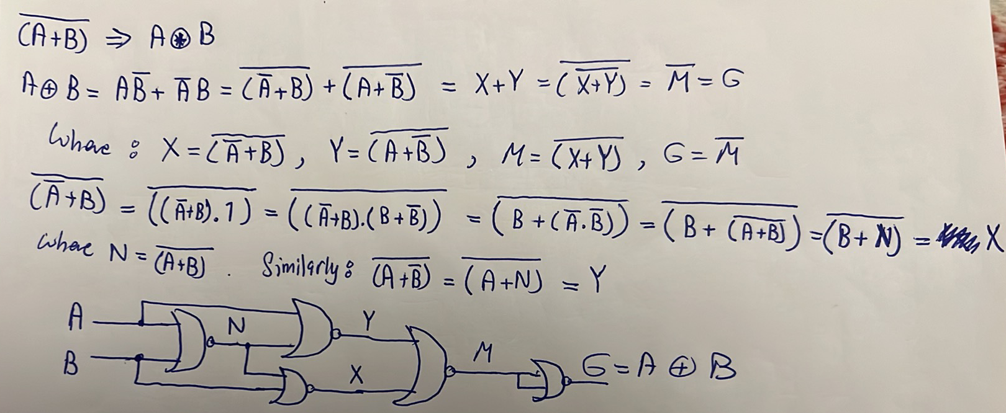
Make an XNOR gate using NOR gates only
- Just remove the last NOR gate in the previous circuit
Does the synthesis tool care about the sensitivity list?
- The sensitivity list cares about the sensitivity list in case of sequential always block only, but it doesn’t care about it in case of combinational always block.
How can we convert a binary counter into a gray counter?
- gray_cnt = (bin_cnt >> 1) ^ bin_cnt;
Implement a 2x1 MUX using an AOI gate
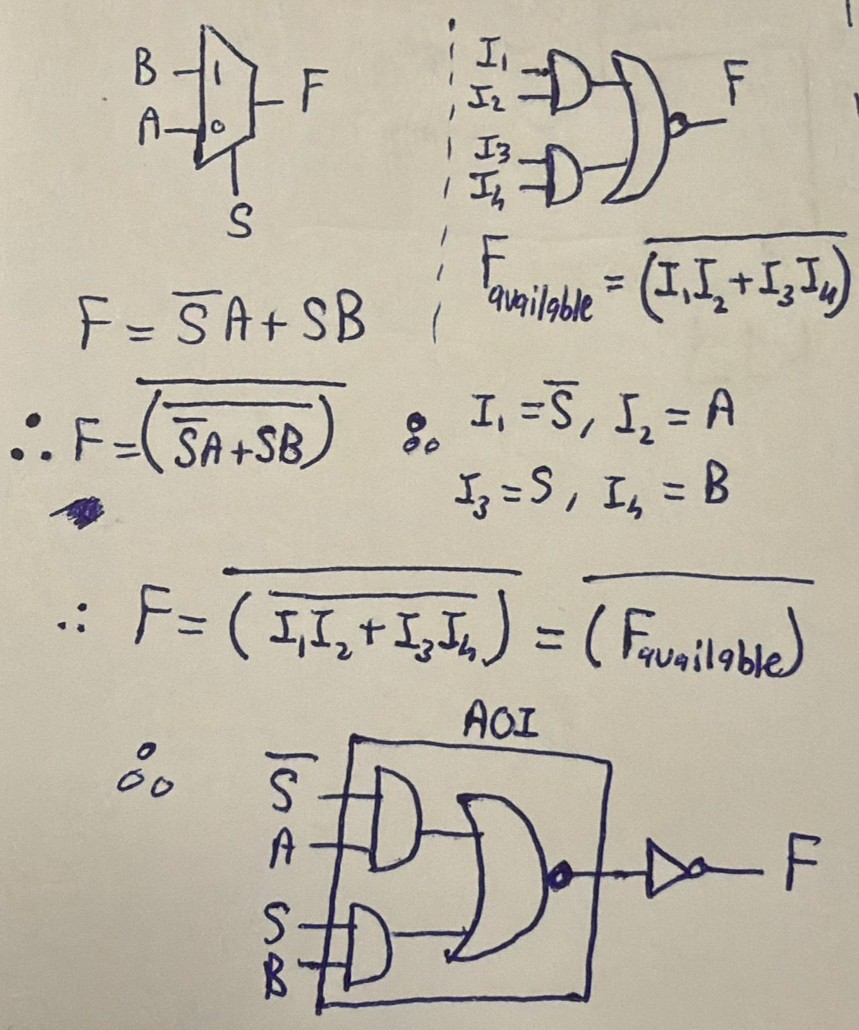

Miscellaneous Questions
Write a Verilog code for an 8-to-3 encoder
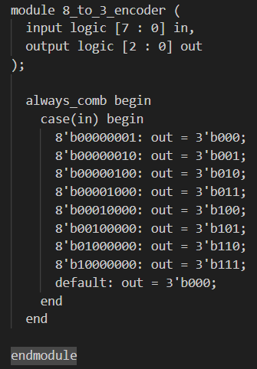
Write a Verilog code for a general encoder
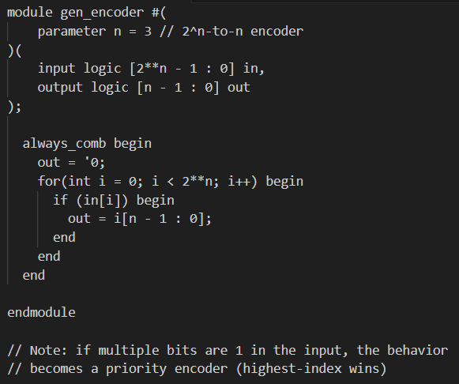
If we set $n=3$ in the previous code, will it get synthesized the same as the first 8_to_3_encoder code?
Almost yes, because both codes reduce at the end to the following equations:
$$out\left[0\right]=in\left[1\right] \left| in\left[3\right] \right|in\left[5\right] | in\left[7\right]$$
$$out\left[1\right]=in\left[2\right] \left| in\left[3\right] \right| in\left[6\right] | in\left[7\right]$$
$$out\left[2\right]=in\left[4\right] \left| in\left[5\right] \right|in\left[6\right] | in\left[7\right]$$
The only difference is that: gen_encoder exactly implements these equations, but 8_to_3_encoder implements these equations only if the input is one-hot. If the input to 8_to_3_encoder is not one-hot, it doesn’t apply the equations, the output is assigned zero directly. We can think of it as follows:
$$8_to_3_encoder output=is input one-hot ? gen_encoder output : 0$$
How can a Verilog code be for a decoder?
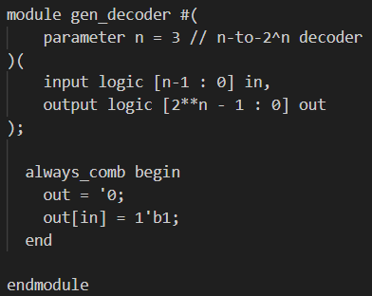
How can we check parity?
Even parity means the number of ones is even, while odd parity means the number of ones is odd. Since the output of an XOR gate is 1 when the number of input ones is odd, an XOR gate checks (or generates) odd parity.

Temsah PnR

